**Assignment no-7**

**Programming Questions on Array**

1)Write a program to print elements of Array ?

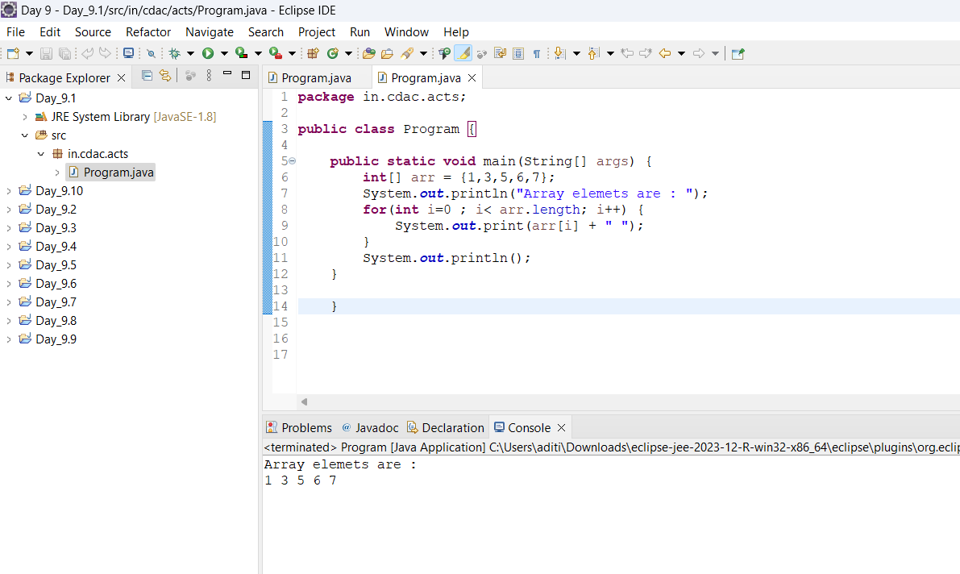

2) Write a Java program to check the equality of two arrays?

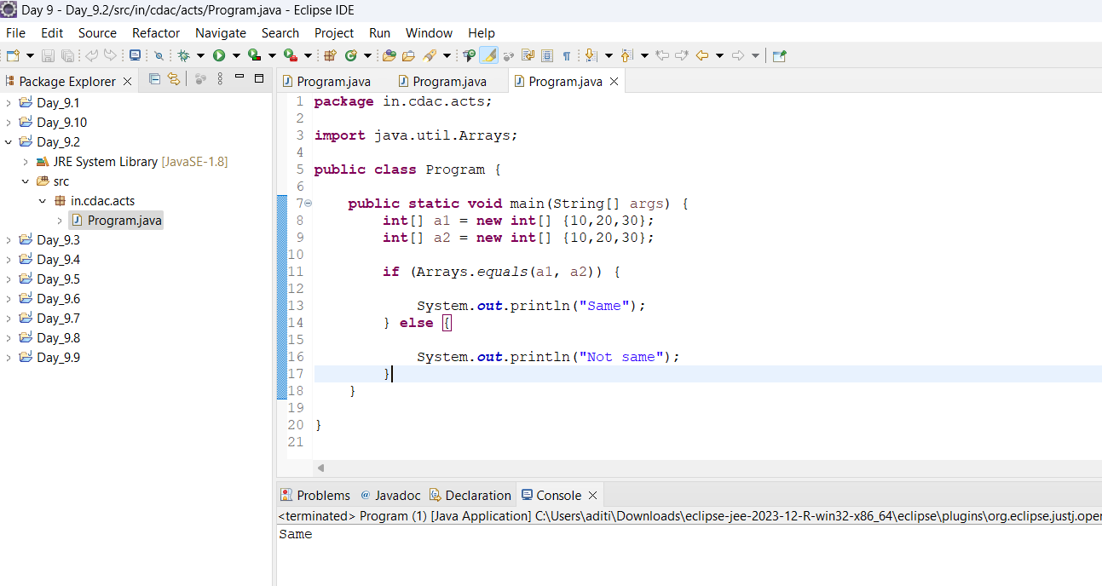

3) Write a Java program to find all pairs of elements in an integer array whose sum is equal to a given number?

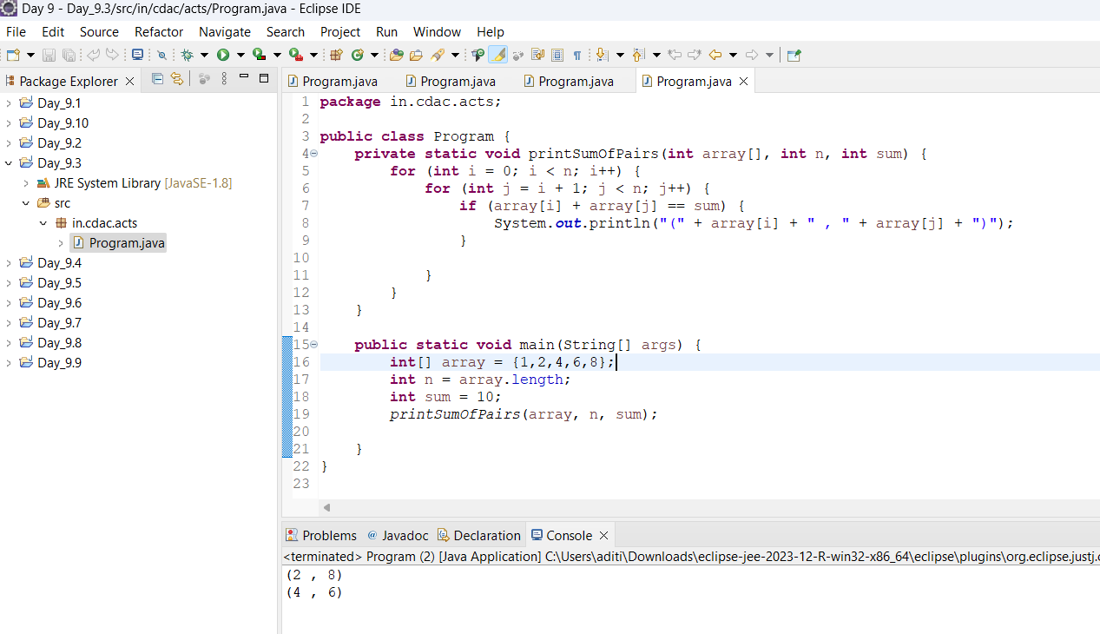

4)Write a program to reverse an Array in java .

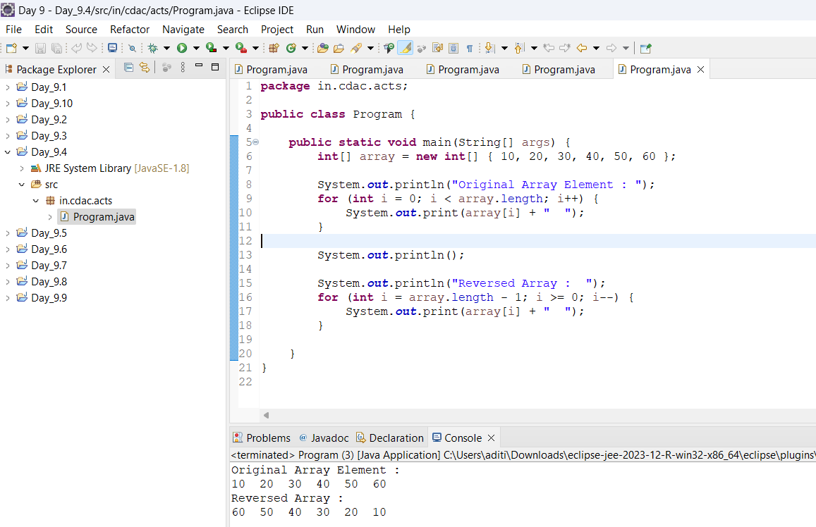

5) Find out smallest and largest number in a given Array?

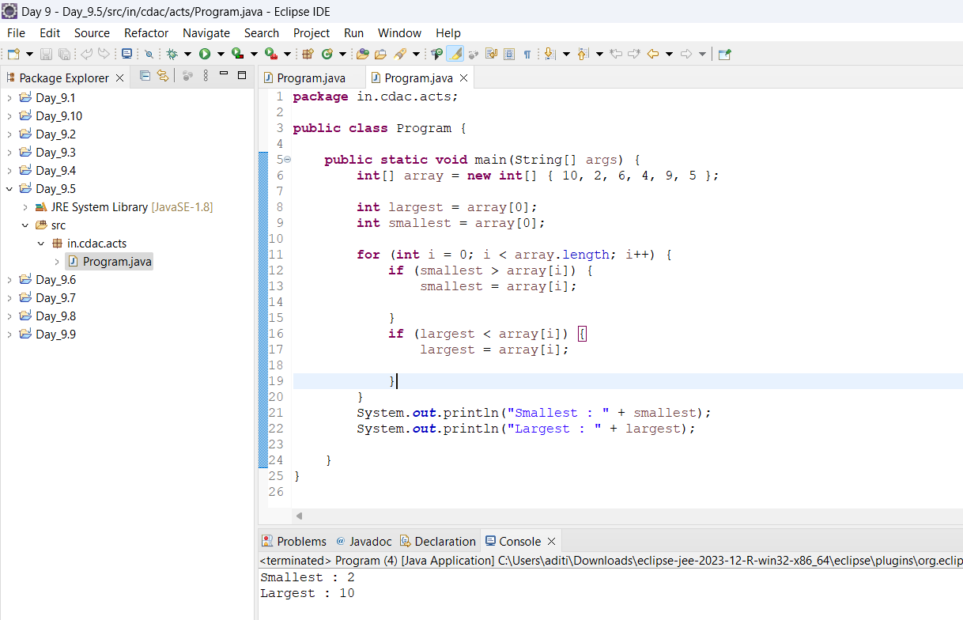

6) .Print the third-largest number in an array without sorting it

Input: [ 24,54,31,16,82,45,67]

Output: 54 (82 and 67 are the largest and second-largest)

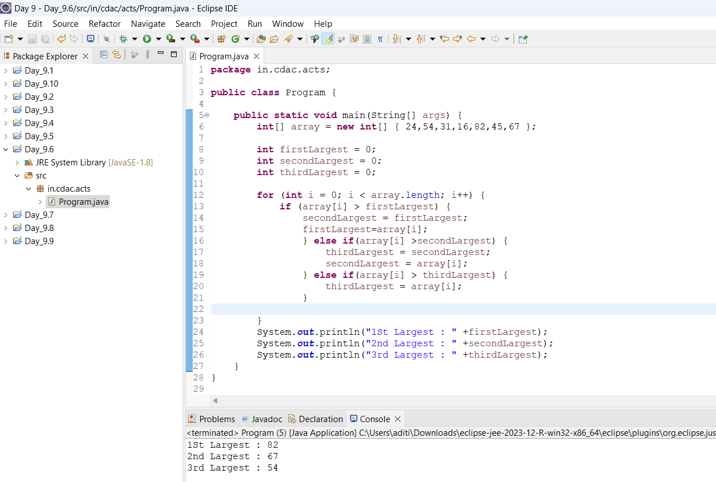

7)Write a program to merge two arrays of integers by reading one number at a time from each array until one of the array is exhausted, and then concatenating the remaining numbers.

Input: [23,60,94,3,102] and [42,16,74]

Output: [23,42,60,16,94,74,3,102]

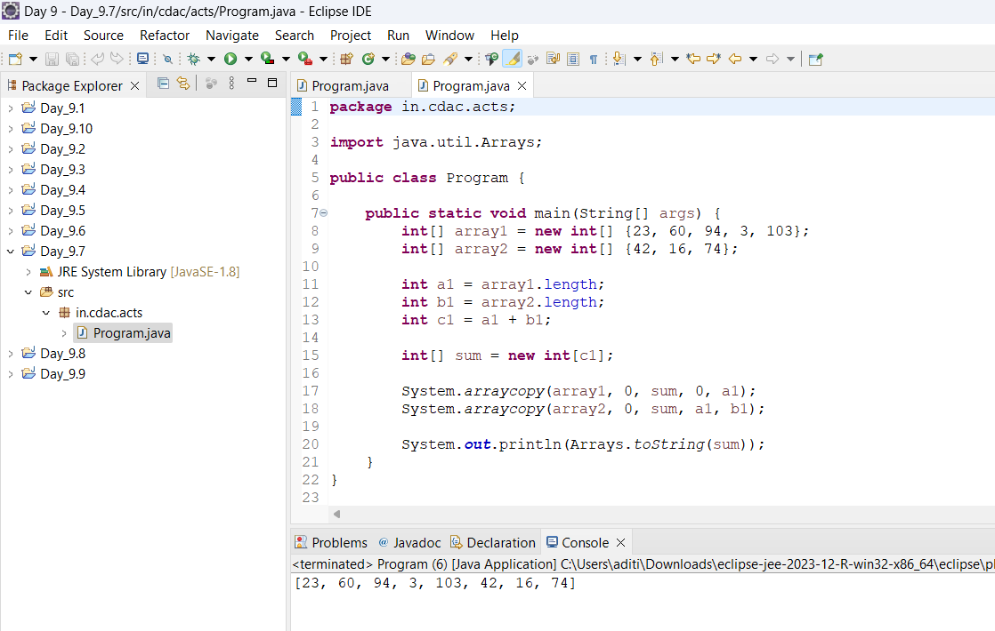

8).Write a program which takes an array of integers and prints the running average of 3 consecutive integers.

In case the array has fewer than 3 integers, there should be no output.

Input: [5,14,35,89,140]

Output: [18, 46, 88]

(Explanation: 18=(5+14+35/3, 46=(14+35+89)/3, ...)

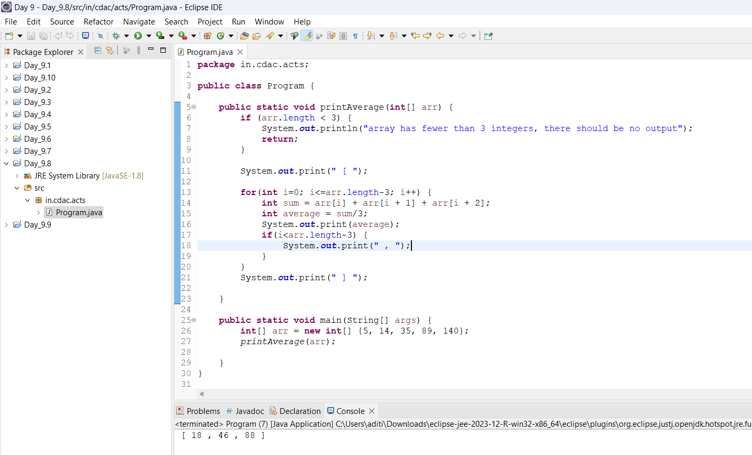

9) Write a program which generates the series 1,4,27,16,125,36

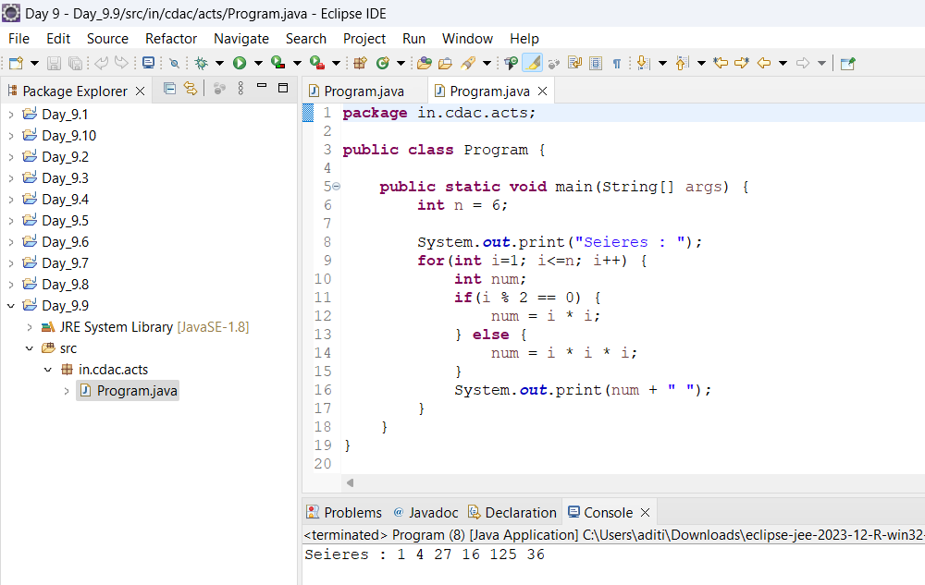

10) Given an array of integers, print whether the numbers are in ascending order or in descending order or in random order without sorting

Input: [5,14,35,90,139] Output: Ascending

Input: [88,67,35,14,-12] Output: Descending

Input:[65,14,129,34,7]Output:Random

